HS1-42
AC-DC pulse type closed-loop stepper driver

User's Manual V1.0.0

Shenzhen Grui iot Technology Co., LTD

CONTEXTS
1. Product Introduction 1
1.1 Product Overview 1
1.2 Product Feature 1
1.3 application area 1
1.4 Naming rules 1
2. Electrical, mechanical and environmental indicators 1
2.1 Mechanical installation drawing 1
2.2 Enhanced heat dissipation system 1
2.3 Electrical indicators 1
2.4 Use environment and parameters 1
3. Driver interfaces and cable connections are introduced 1
3.1 Interface diagram 1
3.2 Interface description 1
3.2.1 Control signal interface 1
3.2.2 Output signal interface 1
3.2.3 Brake control interface 1
3.2.4 Encoder interface 1
3.2.5 Motor control output interface 1
3.2.6 Power input interface 1
3.2.7 Burn debug interface 1
3.3 Status Indicator 1
3.4 Input control signal 1
3.4.1 Input control signal interface circuit 1
3.4.2 Control signal timing diagram 1
3.4.3 Control signal mode Settings 1
3.5 Output control signal 1
3.5.1 AM interface for alarm, in place output use 1
3.5.2 BK Interface control brake motor (reserved) 1
3.6 Wiring requirements 1
4. Dip switch function setting 1
4.1 Subdivision setting 1
4.2 Direction setting 1
4.3 Alarm polarity setting 1
4.4 Algorithm selection 1
4.5 Smoothing coefficient setting 1
5. Power supply selection 1
6. Light and alarm indication 1
7.Warranty and after- sale service 1
7.1 Warranty service 1
7.1.1 Free warranty service 1
7.1.2 No warranty situation 1
7.2 Changing or Refunding 1
7.2.1 Replacement due to product failure 1
7.2.2 Non-product failure replacement 1
7.3 Sales return 1
7.4 Post-sales service 1
8.Revision history 1

Product Introduction

1.1 Product Overview
The HS1-42 AC-DC pulse closed-loop stepper driver is the latest one launched by Gree Internet of Things Technology Co., LTD., using the latest dedicated motor control digital signal processor, is an advanced motion control device, combining the advantages of traditional stepper drivers and closed-loop feedback systems. It provides higher accuracy, greater torque output, and lower drive noise.
HS1-42 has the brake output control function, which can stably output about DC24V voltage within the working voltage range, and users can directly access the brake power line (pay attention to distinguish positive and negative), and there is no need for external relays and other devices in the middle, which can greatly facilitate users' use.
HS1-42 with serial debugging function, communication using MINI USB interface, users can set subdivision, current, working mode and other parameters through PC PC debugging software, greatly enrich the practical function of the product, can meet the vast majority of applications.

1.2 Product Feature

●Small size, easy to install
●With brake output control interface, and the relay intermediate control is not required
●The new generation of 32-bit ARM technology has good stability, strong compatibility and high cost performance
●External dip sets drive segmentation, initial direction, alarm polarity, algorithm, smoothing factor
●Optical isolation of differential signal input
●Built-in micro division, low speed stability is excellent
●Pulse response frequency up to 200KHz (higher can be changed)
●Subdivision setting range 200-60000(can be set by the host computer)
●Precision current control greatly reduces motor heating
●Low vibration and low noise
●It has alarm protection functions such as overpressure and overdifference
●Input voltage range： DC 24V~50V / AC 18V~36V

1.3 application area
Suitable for a variety of small and medium-sized automation equipment and instruments, such as: engraving machine, marking machine, cutting machine, plotter, CNC machine tools, automatic assembly equipment. The application effect is especially good in equipment applications where users expect low noise and high speed.

1.4 Naming rules
Drive model naming rules, as described below：
HS 1-42--
① ② ③ ④ ⑤ ⑥

序号 | 含义
① | Distinguish between 2-phase and 3-phase; Empty：2-phase drive;
② | Product series name; HS：Hybrid servo drive;
③ | Product series number; 1：Series number is 1;
④ | Match the motor base; 42：Mainly matching motors with 42 baseplates;
⑤ | Special function code;
⑥ | Design change code;

Electrical, mechanical and environmental indicators

2.1 Mechanical installation drawing
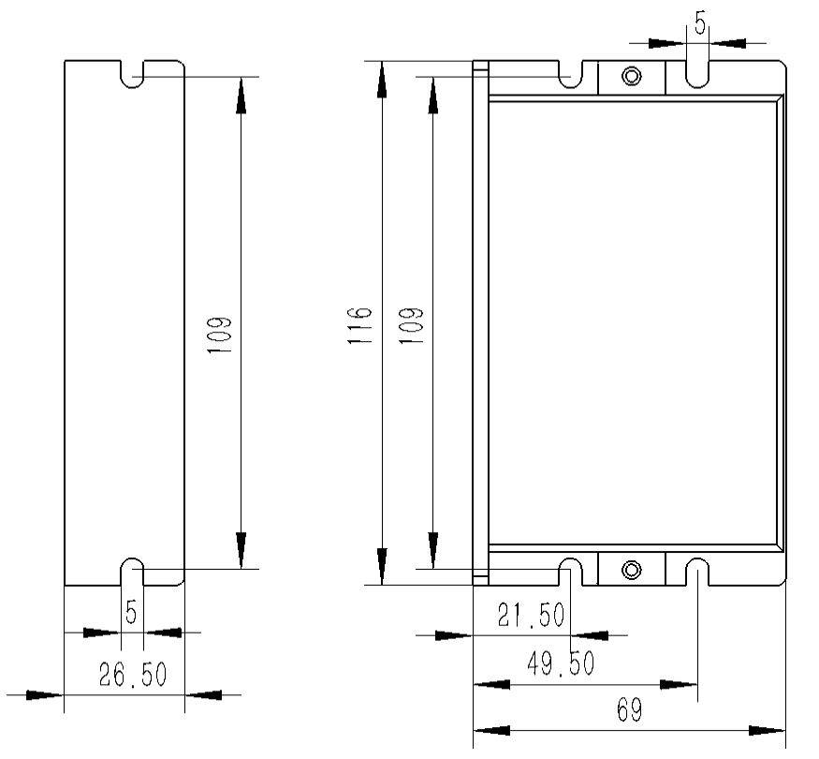
Side mounting drawing Front mounting drawing
Figure 2.1 Installation dimensions (unit: mm)
It is recommended to use the side installation, the heat dissipation effect is better, in the design of the installation size, need to consider the size of the terminal and wiring！

2.2 Enhanced heat dissipation system
- The reliable operating temperature of the driver is usually within 50 ° C, and the operating temperature of the motor is within 80 ° C;
- When installing the driver, please use the side mounting, and make the driver bottom surface to form a +strong air convection; When necessary, a fan is installed near the driver in the machine to form air convection, auxiliary drive heat dissipation, and ensure that the driver works within a reliable operating temperature range.

2.3 Electrical indicators
Explanation | HS1-42
Explanation | minimum | Typical value | Maximum | unit
Input DC power supply voltage | 24 | 24 | 50 | VDC
Input the AC power supply voltage | 18 | 18 | 36 | VDC
Control signal input current | 7 | 10 | 16 | mA
Step pulse frequency | 0 | - | 200 | KHz
Insulation resistance | 50 |  |  | MΩ

2.4 Use environment and parameters
Cooling method |  | Natural cooling, fan cooling
Use Environment | occasion | Can not be placed next to other heating equipment, to avoid dust, oil mist, corrosive gases, humidity is too large and strong vibration places, flammable gases and conductive dust are prohibited
Use Environment | temperature | 0——50℃
Use Environment | humidity | 40—90%RH
Use Environment | vibration | 10~55Hz/0.15mm
storage temperature |  | -20℃~65℃

Driver interfaces and cable connections are introduced

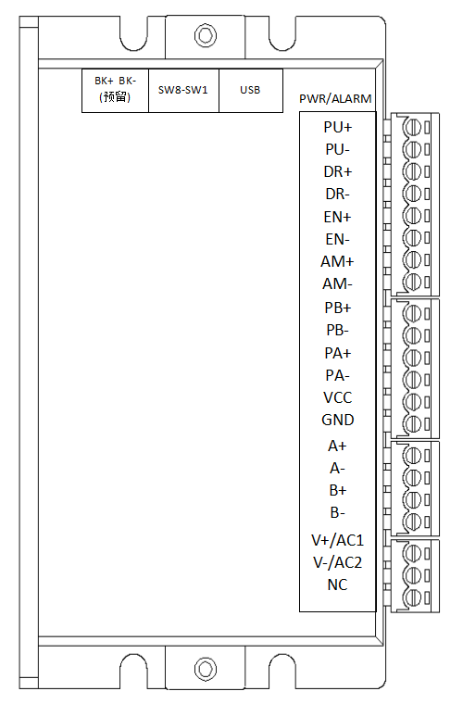
3.1 Interface diagram

Figure 3.1 Interface diagram of HS1-42

3.2 Interface description
The HS1-42 AC-DC pulse type closed-loop stepper driver adopts 3.81-3P terminal for power interface, 3.81-8P terminal for signal control interface, 3.81-6P terminal for encoder and 3.81-4P terminal for motor interface. The interface is defined in the following sections.

3.2.1 Control signal interface
Name | Function
PU+ | Pulse control signal: +5V-+24V can be driven, the rising edge is effective, every time the pulse from low to high, the motor takes a small step. In order to reliably respond to the pulse signal, the pulse width should be greater than 2.5μs.
PU-
DR+ | Direction control signal: +5V-+24V can be driven, high/low level signal. In order to ensure the reliable commutation of the motor, the direction signal should be established at least 50μs before the pulse signal.
DR-
EN+ | Enable control signal: +5V-+24V can be driven, high/low level signal. Used to enable or disable the operation of the motor. When EN+ is connected to +5V and EN- is connected to low voltage level, the driver will cut off the current of each phase of the motor so that the motor is in a free state, and the stepping pulse is not responded at this time. When this function is not required, enable the signal terminal to hang. In addition, the EN end can also be used to clear out-of-tolerance alarm signals.
EN-

3.2.2 Output signal interface
The output signal interface is used as the alarm output function by default, and the output signal is effective when the alarm of overvoltage or out-of-position occurs. In addition, the output interface can also be set to the output function through the PC software, and the user can make corresponding Settings according to the actualuse.
Name | Function
AM+ | AM+ alarm signal output: When overvoltage, position out-of-tolerance alarm occurs, the alarm signal output is effective;  Maximum driving current 50mA.
AM-

3.2.3 Brake control interface
Name | Function
BK+ | Brake control signal output: when overvoltage, position out of the alarm, the BK port output signal is effective, control brake lock;
BK-

3.2.4 Encoder interface
Name | Function
PB+ | Encoder B phase input interface, pay attention to the line sequence.
PB-
PA+ | Encoder phase A input interface, pay attention to the line sequence.
PA-
VCC | Encoder 5V power supply positive end.
GND | Encoder 5V power supply negative end.

3.2.5 Motor control output interface
Name |  | Colour | Explanation | Function
Motor | A+ | Red | Motor interface | Two phase stepper motor wiring port, need to pay attention to the line sequence
Motor | A- | Blue | Motor interface
Motor | B+ | Green | Motor interface
Motor | B- | Black | Motor interface

3.2.6 Power input interface
Name |  | Explanation | Function
Power | V+/AC1 | Power interface | Power input range：DC24V~50V/AC18V~36V
Power | V-/AC2 | Power interface | Power input range：DC24V~50V/AC18V~36V

3.2.7 Burn debug interface
The serial port communication interface of HS1-42 driver adopts MINI USB interface, which can be connected to PC through USB to TTL serial port conversion tool through the special debugging cable provided by our company. It is forbidden to plug and unplug when live! Through the PC side, the customer can set the required parameters, such as current, subdivision, working mode, etc., the specific can see the PC software interface.
Terminal number | Symbol | Name | Function
1 | NC | - | Used inside the device
2 | NC | - | Used inside the device
3 | GND | Serial port | 0V
4 | NC | - | Used inside the device
5 | NC | - | Used inside the device
6 | NC | - | Used inside the device
7 | RXD | Serial port receiver
8 | TXD | Serial port transmitter
▶ Note: The debugging line connected between HS1-42 and PC is a dedicated line (attached according to user conditions), which should be confirmed before use to avoid damage.

3.3 Status Indicator
The indicator light of HS1-42 AC-DC pulse type closed-loop stepper driver is an internal compact patch LED, and its basic definition is shown in the following table.
Name | Function | Explanation
Green LED | Power supply, save parameter function indicator, restore factory setting function indicator,dip switch status indicator,Alarm light | When the power is normal, the green light is on and the red light is off. When factory Settings are restored, DIP status is switched, and equipment is abnormal, the traffic light blinks alternately. See Chapter 5 for the flashing rule.
Red LED

3.4 Input control signal

3.4.1 Input control signal interface circuit
HS1-42 driver control signal end adopts differential interface circuit, can be used for differential signal, single-ended common negative and common positive interface, built-in high-speed optocoupler, in the harsh environment, strong anti-interference ability. The interface circuit diagram is shown in Figure 3.2.

图3.2 Input interface circuit
▶ Note: HS1-42 is a 5V-24V universal driver, so no series resistance is required at the signal control end!

3.4.2 Control signal timing diagram
In order to avoid some misactions and deviations, PU, DR And EN should meet certain requirements, as shown in the following figure:：
Figure 3.3 Timing diagram of control signal
Annotation：
t1：EN (Enable signal) should be at least 5ms in advance of DR, determined to be high. In general, it is recommended that EN+ and EN- be suspended.
t2：DR At least in advance PU drops along 50μs to determine whether its state is high or low.
t3：Pulse width is not less than 2.5μs.
t4：Low level width is not less than 2.5μs.

3.4.3 Control signal mode Settings
Pulse trigger edge selection: Through the PC software can set the pulse rising edge or falling edge trigger effective.

3.5 Output control signal
After the driver is powered on normally, the effective state of the output interface is normally open by default. Users can also configure the effective state of the output interface to be normally closed by default through the upper computer software on the PC.

3.5.1 AM interface for alarm, in place output use
The following is the wiring diagram of the output signal port when it is used as the alarm output function (the connection method is the same when it is used as the in place output) :
Figure 3.4 Schematic diagram of normally closed connection of output interface
Figure 3.5 Schematic diagram of normally open connection of output interface

3.5.2 BK Interface control brake motor (reserved)
The output outlet of the HS1-42 AC-DC pulse closed-loop stepper driver contains the control function of the brake motor lock, which can directly control the brake lock and release. The following is a schematic diagram:
Figure 3.6 Schematic diagram of brake motor lock device wiring
The specific control process is as follows: when the drive is powered, the effective state of the output interface is normally open output by default, at this time, the brake is in the lock state, when the drive is powered on and stable, and the motor is normally locked, the switch is to the normally closed state, and the brake is loose. If during this period, the drive generates an overvoltage or out-of-tolerance alarm, the control brake is locked again.

3.6 Wiring requirements
- In order to prevent the driver from being interfered with, it is recommended that the control signal use a shielded cable, and the shielding layer is short-connected with the ground wire. Except for special requirements, the shielded cable of the control signal cable is single-ended grounded: the upper end of the shielded cable is grounded, and the driver end of the shielded cable is suspended. The same machine is only allowed to be grounded at the same point, if it is not the real grounding line, the interference may be serious, and the shielding layer is not connected at this time.
- The pulse and direction signal line and the motor line are not allowed to be wrapped together side by side, and it is best to separate at least 10cm or more, otherwise the motor noise is easy to interfere with the pulse direction signal and cause the motor positioning is inaccurate, the system is unstable and other failures.
- If a power supply for multiple drivers, should be connected in parallel at the power supply, do not allow the first to a chain connection.
- It is strictly forbidden to plug and plug the driver's strong electric terminal, and there is still a large current flowing through the coil when the electric motor stops, and the plug and plug terminal will cause a huge instantaneous induced electromotive force to burn the driver.
- Do not connect the wire head to the terminal after adding tin, otherwise the terminal may be damaged by overheating due to the increase in contact resistance.
- The wiring ends should not be exposed outside the terminals to prevent damage to the driver due to an accidental short circuit.

Dip switch function setting
The HS1-42 driver uses an 8-bit dip switch,The detailed function description is as follows:

4.1 Subdivision setting
SW1-SW4 Sets the subdivision of the drive, a total of 16 subdivisions can be set, the dip corresponding to the default subdivision Settings, as shown in the following table: You can also set the corresponding subdivision size of each file independently through the PC software.
Steps/r | SW1 | SW2 | SW3 | SW4 | Explanation
400 | on | on | on | on | The user can independently set the size of each file subdivision through the PC software, setting the range of 200-60000, and the resolution is 1.
800 | off | on | on | on
1600 | on | off | on | on
3200 | off | off | on | on
6400 | on | on | off | on
12800 | off | on | off | on
25600 | on | off | off | on
3600 | off | off | off | on
1000 | on | on | on | off
2000 | off | on | on | off
4000 | on | off | on | off
5000 | off | off | on | off
8000 | on | on | off | off
10000 | off | on | off | off
20000 | on | off | off | off
7200 | off | off | off | off

4.2 Direction setting
SW5 sets the initial rotation direction of the motor. When SW5=off, it is positive rotation. When SW5=on, it is rotated in the opposite direction.
▶ Note: After the DIP switch of direction setting is modified, it takes effect only after the device is powered on again.

4.3 Alarm polarity setting
SW6 sets the default output signal resistance state of alarm. When SW6=off, it is normally on. If SW6=on, the state is normally closed.

4.4 Algorithm selection
SW7 is used to select the control algorithm of the driver. When SW7=off, it is algorithm A. When SW7=on, it is algorithm B.

4.5 Smoothing coefficient setting
SW8 is used to select the smoothing coefficient. When SW8=off, it is the smoothing coefficient 1. When SW8=on, the smoothing coefficient is 2.

Power supply selection
The power supply voltage can work normally within the specified range. The HS1-42 driver can use a transformer for power supply. It is recommended that the AC output voltage of the transformer should not exceed its specified maximum voltage. The HS1-42 driver can also be powered by an unregulated DC power supply, but care should be taken that the voltage ripple peak after rectification does not exceed its specified maximum voltage. It is recommended that users use a DC voltage lower than the maximum voltage to avoid power grid fluctuations beyond the operating voltage range of the driver.
If using a regulated switching power supply, it should be noted that the output current range of the switching power supply should be set to the maximum.

▶Note:
When wiring, pay attention to the position of the power interface, do not connect to the motor port, it is best to confirm whether the connection is correct;
It is best to use non-regulated power supply;
When using a non-regulated power supply, the power supply current output capacity should be greater than 60% of the set current of the driver；
When using a regulated switching power supply, the output current of the power supply should be greater than or equal to the operating current of the driver；
To reduce costs, two or three drivers can share a power supply, but the power supply should be sufficient.

Light and alarm indication
HS1-42 AC-DC pulse type closed-loop stepper driver has a green LED and a red LED, one can be used as a power indicator, the other can be used as a fault indicator, dip status switch indicator, save or restore parameter indicator, the specific relationship is shown in Table 6.1：
When the driver is powered on, the green LED is on, and when the driver is powered off, the green LED is off.
When the DIP switch is flipped, the green LED blinks twice quickly. This is normal, indicating that the DIP switch is effective.
When the driver fails, the traffic light flashes alternately, and its different blinking patterns indicate different fault information. When the fault is eliminated by the user, the green LED remains on and the red LED goes off.
When the parameters are recovered, the traffic light flashes alternately, and when the parameters are saved/recovered, the green LED is on and the red LED is off.
Table 6.1 LED status indication
LED flicker frequency |  | Phenomenon | Explanation
Green LED | Red LED | Green is flashing, red is flashing
0 | - | The green light is on and the red light is off | Drive enable
1 | - | The green light flashes and the red light goes off | Received a pulse signal
1 | 1 |  | Out-of-tolerance alarm
2 | 1 |  | The pulse received in the disabled state
3 | 1 |  | (overvoltage) out-of-tolerance alarm
1 | 4 |  | Over voltage alarm
1 | 2 |  | Restore parameters in the process

7.Warranty and after- sale service

7.1 Warranty service

7.1.1 Free warranty service
The company solemnly promises that all the purchase of the company's products, if in the use of the product itself caused damage, are to provide one year free maintenance services. The return freight of the product shall be borne by both parties in half.

7.1.2 No warranty situation
- The driver is damaged due to the customer's own wiring error；
- Exceeding the rated operating voltage resulting in driver damage；
- The DC power driver is damaged because it is connected to the AC power supply；
- Due to the extremely harsh environment of the customer site, such as humidity, extremely cold, extremely hot and other harsh environmental factors, but did not inform the company in advance, resulting in damage to the drive；
- The customer has removed the drive housing without permission or the serial label number has been torn off；
- 15 days after the customer confirmed the receipt of the goods, the shell was obviously damaged, hit, resulting in damage to the drive；
- Irresistible natural disasters such as fires, earthquakes, tsunamis, typhoons and other factors；
- In the above cases, the company will charge a certain maintenance cost after assessing the interests of all parties, and the remaining cases are permanently free maintenance.

7.2 Changing or Refunding

7.2.1 Replacement due to product failure
For the failure of the new product itself, the company provides three months free replacement service.
After our technical support personnel confirm that the problem is the product itself, the product will be sent back to the company to avoid the time and postage on the round trip. The customer needs to send the faulty product back by express or logistics, and the company will send another new product back to the customer as soon as it is received.
Note: All products of our company have been strictly tested and aged before leaving the warehouse, so the failure of new products is extremely rare. Please be sure to read the instructions carefully or consult our technical support personnel when operating, or our technical support personnel to assist customers remotely.
The following points should be noted when exchanging goods：
（1）The packing must be complete when sent back to avoid damage during delivery；
（2）Please make sure that the attached parts are complete when exchanging；
（3）Each drive should be independently packaged with the original box to avoid secondary damage to the product during transportation；
（4）If the drive is confirmed after the test is not a product fault, but the customer's own negligence, mistakenly thought that the drive is faulty, the company does not bear the freight (the customer's own negligence includes: the wrong line caused by the drive is damaged, poor wiring mistakenly thought that the drive is damaged, operation error caused the drive can not be used normally, etc.).

7.2.2 Non-product failure replacement
If the customer is not satisfied with the appearance or function of the received product and wants to replace it with a better drive, he can apply to the company for replacement service within one week of receiving the product. After verification, the company will return the product, and the company will replace other products for customers under the condition of confirming that the returned product has no damage in appearance, complete accessories and good packaging. For the replacement of the product, if there is a price difference, the price difference is partially made up by the customer.
Note: The replacement product will no longer enjoy the non-product failure replacement service. The return freight and other costs generated by non-product fault replacement service are borne by the customer!

7.3 Sales return
The company provides 7-day return service for products with quality problems. If you find quality problems within 7 days of receiving this product (subject to the actual receipt date of the customer), please communicate with our salesman or technical support personnel in a timely manner. After the company's technical support personnel confirm the quality problems of the company's products themselves, The customer will then return the original complete product, its internal and external packaging, accessories and shipping notes to the company by express or logistics.
If the customer still insists on returning the goods after the company has checked and confirmed that it is correct, the return freight and all other expenses incurred therefrom shall be borne by the customer.
The following points should be noted when returning goods：
（1）Refund method Please contact the relevant department of the company before implementing the refund；
（2）The product must be in new condition and fully packaged. Please send it back to us by Courier or logistics；
（3）Product appearance damage, incomplete accessories and other problems caused by customers will not be accepted；

7.4 Post-sales service
If you need after-sales service support when using this product, you can contact the company at the first time.
National toll-free service hotline：0755-23206995；
Technical specialist service hotline：18576758897(Mr. Xie)、17666115681(Mr. Tuo)；
Service hours: Monday to Friday 8:30-17:30 (except national holidays).

8.Revision history
version number | Explanation | Change deadline | Developer/auditor
V1.0.0 | Initial use version; | 2025.03.29 | TCJ/XH

